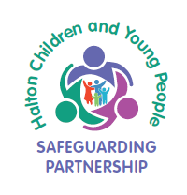

Multi-Agency Audit
Feedback and Evaluation Form
Please state the name of your Organisation

Comments
Please use the box below to comment on your recent experience of the Multi-Agency Audit.
This can include what you thought was useful about the process and any comments that you have to improve the process, including the documentation being used, the focus groups that you are asked to attend and any other thoughts or opinions that you have.
Many thanks for your involvement and continued support.
Please return completed form to Angela.houghton@halton.gov.uk

