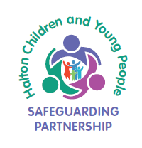
Halton Children and Young People
Safeguarding Partnership

Learning Conversation with Professionals

Prompt Sheet for Multi-Agency Auditors
Suggested Questions
- Why have you been involved in this case and what are you specifically hoping to achieve in terms of outcomes for the child?
- At key points has there been timely decision making? (please give examples)
- Describe a day in the life … at home, at school and in the local area.
- Do you know if the child feels that you have made a difference and how do you know?
- How do you ensure that the child/young person’s voice is heard and how has this been used and shared to influence your practice, the plan and your service?
- In your partnership working, what is working well? (specifically ask about communication)
- Is there anything that’s not working well? If yes, do you have any suggestions about how this can be improved?
- Have there been any points during the case where you have felt the need to challenge (outcome?) or you have been challenged? (outcome)
- What supervision do you have on this case? Is this helpful and why?
- How do you know that you are responding at the right level of need?
- What difference have the interventions/ delivery of services made for this child/young person? What is the evidence of this?
Note to Auditors: please feel free to develop additional and specific questions arising from your review and discussion of the actual forms returned.

